Data MANIPULATION Languages (DML)
1.Add two product categories of your choice
Query:

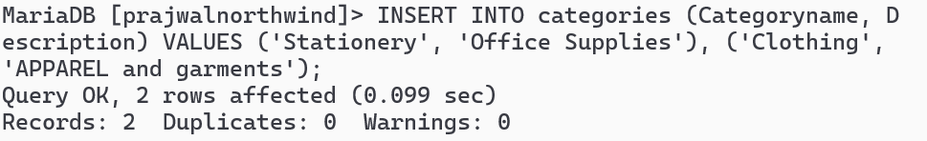

2.Add 3 new suppliers in suppliers table
Query:

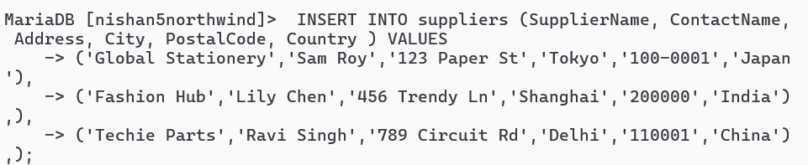
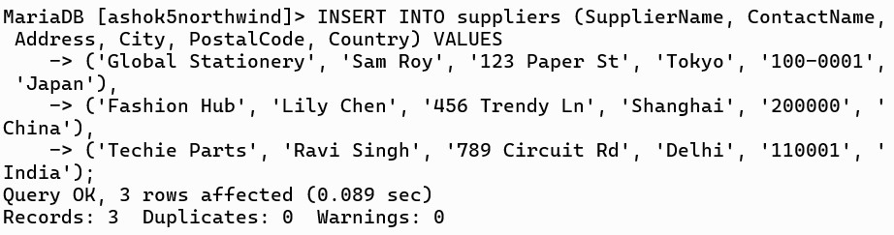

3.Add 5 new customers in customers table
Query:

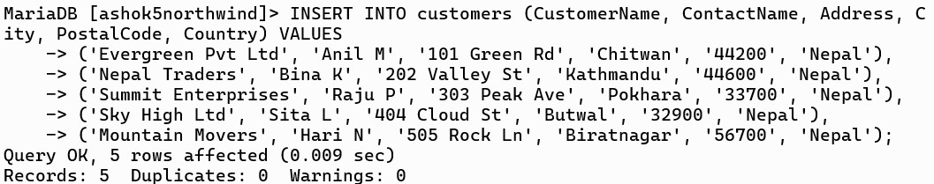

4.Add 4 products in product table
Query:

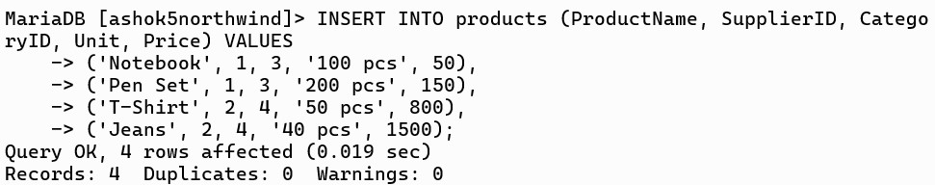
5.Add 3 new employees.
Query:

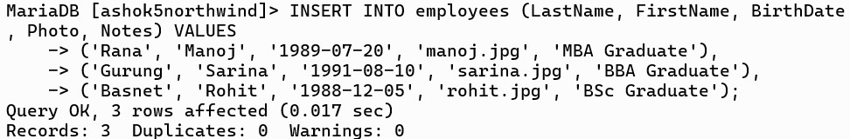

6.Update all customers from Brazil to Singapore
Query:

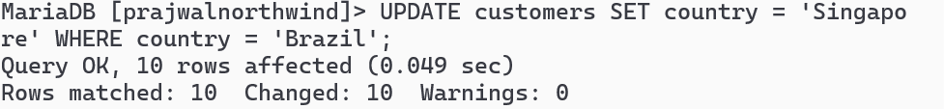

7.Update customers table changing name of Madrid City to Bangalore
Query:

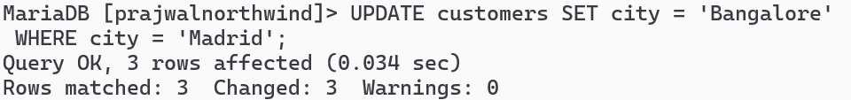

8.Update all German customer to Bhutanese customers
Query:

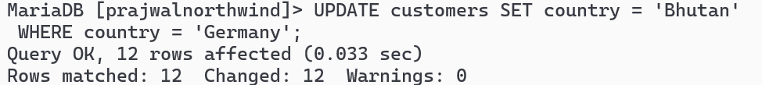
9.Convert all Spanish customer to Thai Customers.
Query:

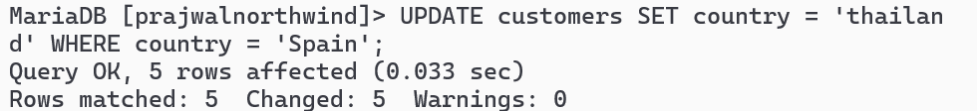

10.Convert all customers of London to Kathmandu customers also change name of country.
Query:

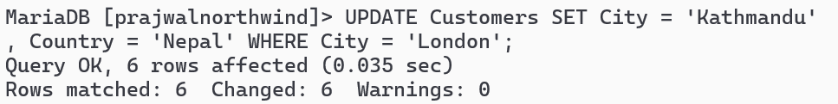
11.Convert customers from G7 Countires to SARCC Countries.
Query:

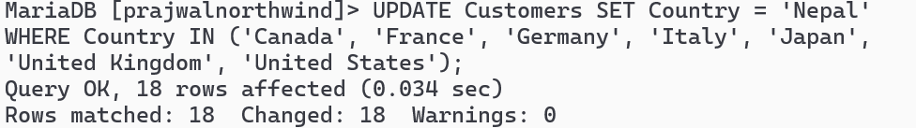

12.DELETE all records from orders and orderdetails.
Query:
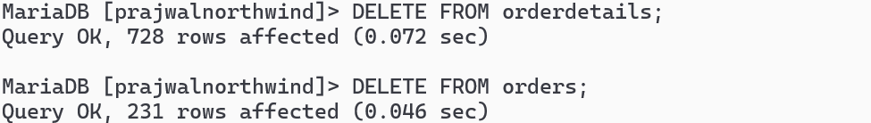

13.DELETE all from customers who have PostalCode containing 31
Query:

14.DELETE all from customers having PostalCode containing 00 and from Rome or Paris.
Query:

15.DELETE all from customers who are not from Salzburg
Query:

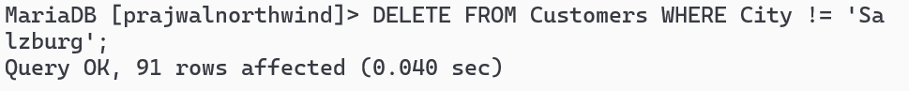

16.DELETE all employees who are born on July
Query:

17.DELETE all employees who are born on August
Query:

18.DELETE all product from seafood and beverages categories;
Query:

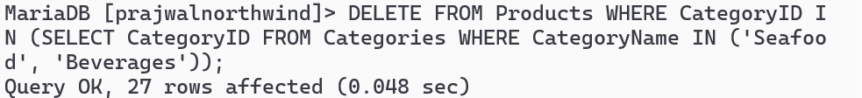
19.Find name and count of suppliers from different countries.
Query:

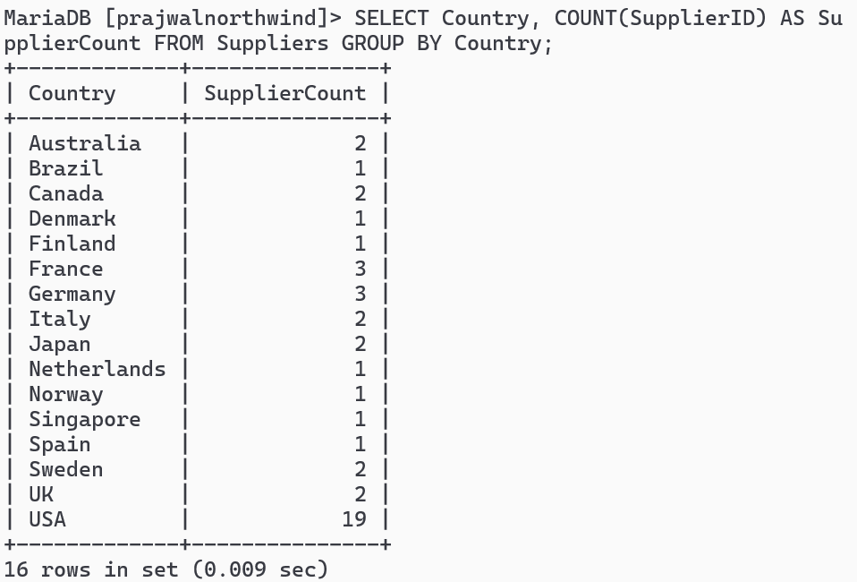

20.Find name and count of customers from different cities.
Query:

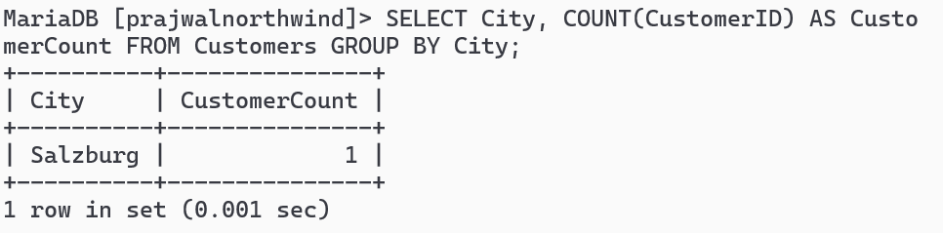

21.Find number of orders made by employee along with employeeID Query:

